Build Python Code

|  |  |
| --- | --- |
| Team Id | PNT2022TMID39958 |
| Project | AI-Powered Nutrition Analyzer for Fitness Enthusiasts |

**Importing Libraries**

The first step is usually importing the libraries that will be needed in the program.

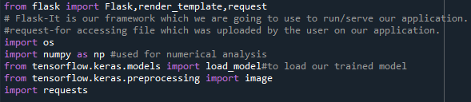

Importing the flask module into the project is mandatory. An object of the Flask class is our WSGI application. Flask constructor takes the name of the current module ( name ) as an argument Pickle library to load the model file.